**Database design: Escape Room Game Design and Player Analytics Platform**

**Project Overview:** Design a MySQL database for an escape room business that allows game designers to manage different escape room scenarios, track team progress through rooms, record success rates, and analyze player behaviors. The database supports managing different escape room experiences, logging player actions, tracking team completions, and providing analytics on game difficulty and player performance.

1. **Populate the tables with data:**

***Write 3 query examples that queries the database and provides insight in the data.***

Følgende spørgsmål bliver bevist med en query:

*Spørgsmål 1: Hvor lang tid tog det i gennemsnit at få alle spillere til at solve deres respektive escaperooms?*

* Som ovenstående query beviser, tog det i gennemsnit 16,5 minutter at gennemføre escaperooms.
* Note: Jeg fandt frem til funktionen ”TIMESPAMPDIFF” på følgende link: <https://stackoverflow.com/questions/10907750/calculate-difference-between-two-datetimes-in-mysql>

*Spørgsmål 2*: Hvor mange hints blev der anmodet om af hver spiller, og hvilke spillere brugte flest hints?

I denne query kan man se, at alle spillere hver især anmodede om 2 hints.

Der var ikke nogen spillere, der brugte flere hints end andre.

*Spørgsmål 3*: Hvilket hold tog længst tid at gennemføre et escaperoom?

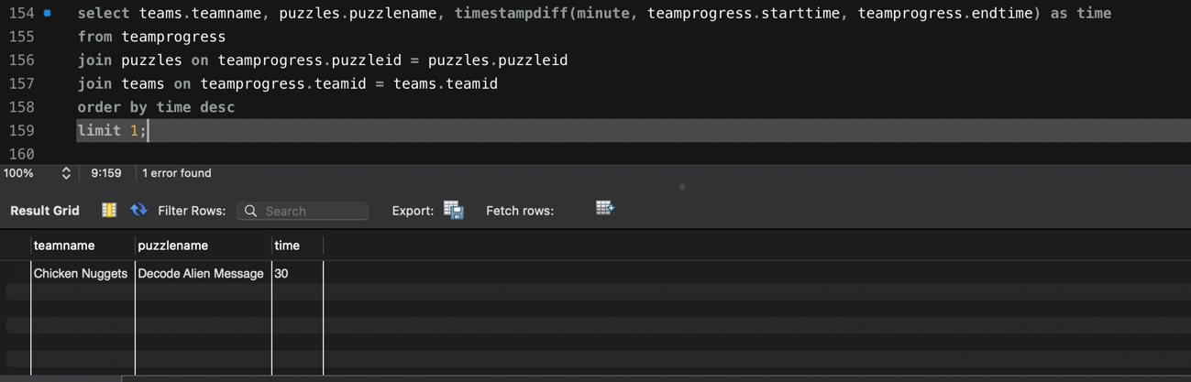

* Her kan man se, at det var teamet ”Chicken Nuggets”, der tog længst tid om at gennemføre sit escaperoom.

1. **Export an EER diagram showcasing the database design**

**Query data**

Find the data in the **World database:** https://dev.mysql.com/doc/index-other.html

**1. Find Countries with a Population Greater Than the Global Average**

**Exercise:** Write a query to find all countries where the population is greater than the average population of all countries in the dataset.

* A screenshot of a computer

  Description automatically generated



**2. Top 5 Most Spoken Languages**

**Exercise:** Write a query to find the top 5 most spoken languages in the world, along with their total number of speakers.

* A screenshot of a computer

  Description automatically generated



Ovenstående query viser et overblik over de 5 mest talte sprog i verden. Derudover får man også indblik i, hvor mange mennesker i verden, der taler det specifikke sprog.

**3. Calculate the Population Density**

**Exercise:** Write a query to calculate the population density (population / area) for each country, and return the country name along with its population density. Only include countries with a non-zero area.

**4. Countries with No Cities**

**Exercise:** Write a query to find all countries that do not have any cities listed in the cities table.



* I ovenstående query kan vi se, at der er 7 lande, der ikke har nogle byer nævnt i vores datasæt.

**5. Average Life Expectancy by Continent**

**Exercise:** Write a query to calculate the average life expectancy for each continent. Include the continent name in the result.

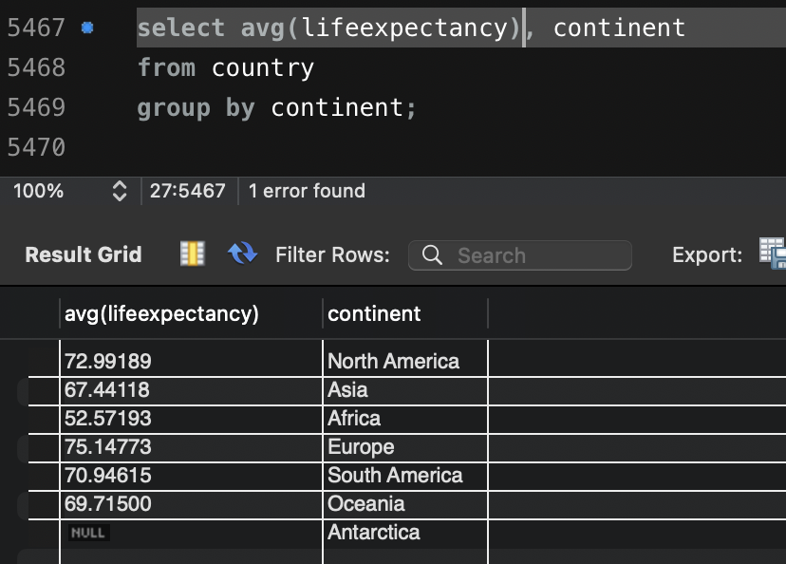

**6. Cities in Countries with Similar Population**

**Exercise:** Write a query to find cities in countries that have a population within 10% of the population of 'Japan'. Display the city name, country name, and population.

* A screenshot of a computer

  Description automatically generated



Her kan vi se, at der er 486 byer i verden, der har indbyggere af hvad der svarer til 10% af Japans indbyggertal.

**7. Rank Countries by GDP**

**Exercise:** Write a query to rank countries by their GDP in descending order. Show the country name and its GDP, and add a rank column.

* 

**8. Countries with a Higher GDP than Their Neighboring Countries**

**Exercise:** Write a query to find countries whose GDP is higher than that of any of their neighboring countries. Assume neighboring countries are defined by the neighbor relationship in the countries table.

**9. Language Distribution Across Countries**

**Exercise:** Write a query to find the number of countries where each language is spoken. Show the language and the count of countries speaking that language, ordered by the count in descending order.



**10. Cities with Population Greater than Their Country’s Average**

**Exercise:** Write a query to find all cities where the city population is greater than the average population of their respective countries. Show the city name, country name, and both populations.

